Photo credit: Indiana University
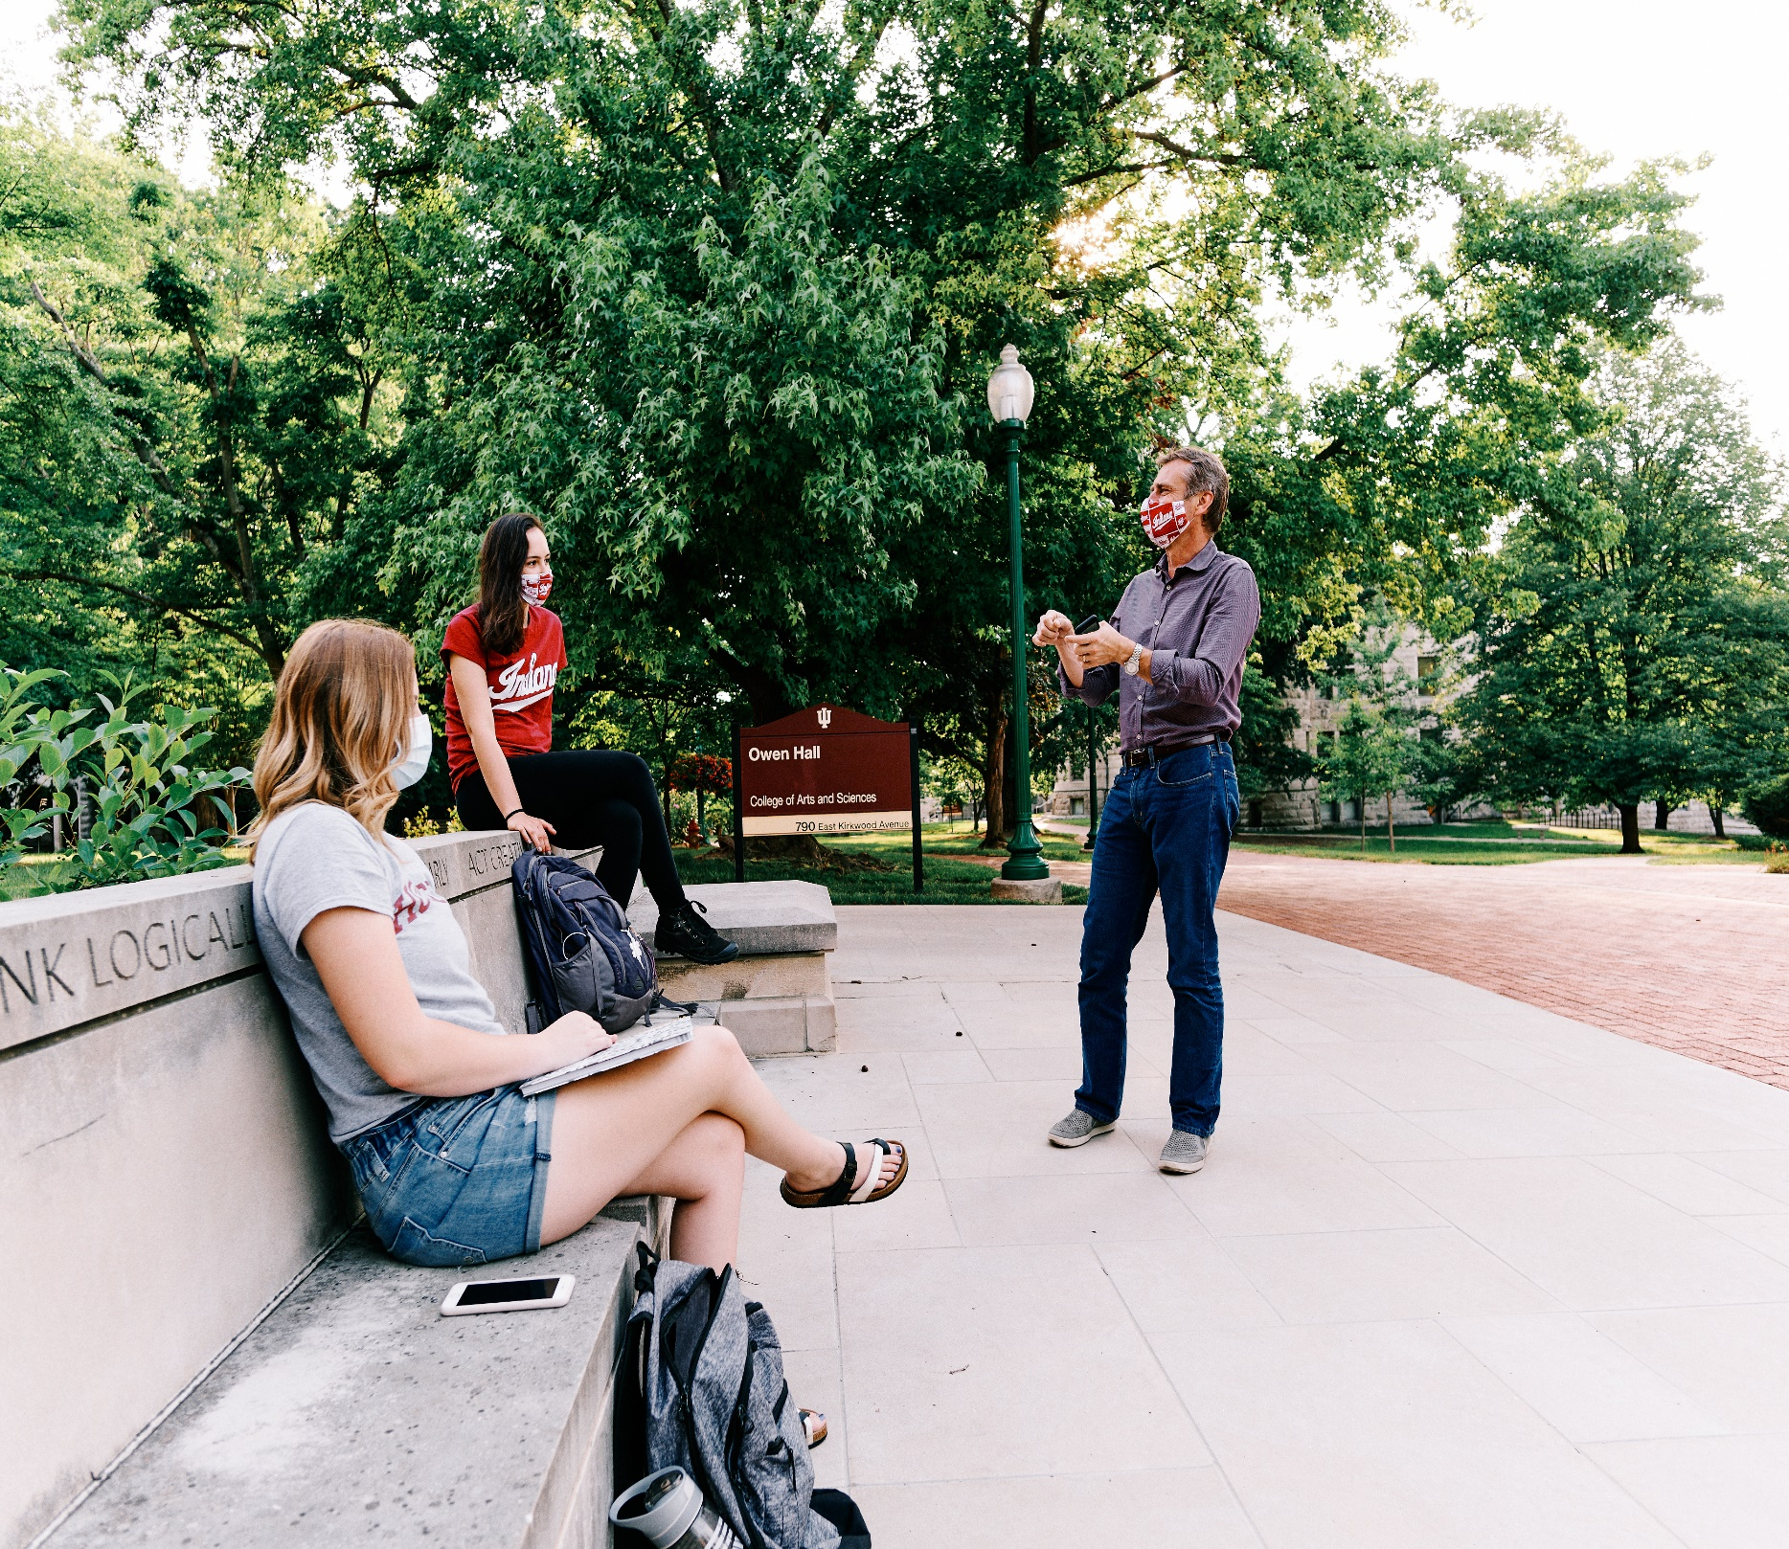

The COVID Pivot and Quality of the Undergraduate Experience
NSSE Pulse Project Report

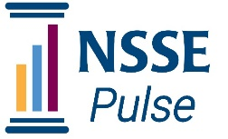

MARCH 2021

Center for Postsecondary Research
School of Education
Indiana University Bloomington

The COVID Pivot and Quality of the Undergraduate Experience

NSSE Pulse Project Report

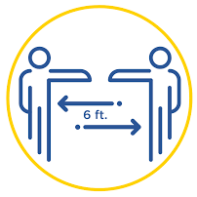
The pandemic of 2020 upended many aspects of higher education while complicating the enduring challenge to live up to our principles regarding a high-quality education for all students. The 2020–21 academic year demanded rapid adaptation to unprecedented and unpredictable circumstances, including more remote and hybrid instruction, canceled and postponed experiences, shifting academic calendars, and more to ensure a safer undergraduate experience.

In addition, during this year of a national reckoning on race, colleges and universities have redoubled efforts to create inclusive and equitable learning environments and to ensure every student has the opportunity to succeed.

Amidst these difficult and changing circumstances, it is essential that institutions continue to ground their response and adaptation in their students' experiences while continuing to support educators’ efforts to implement known, effective educational practices.
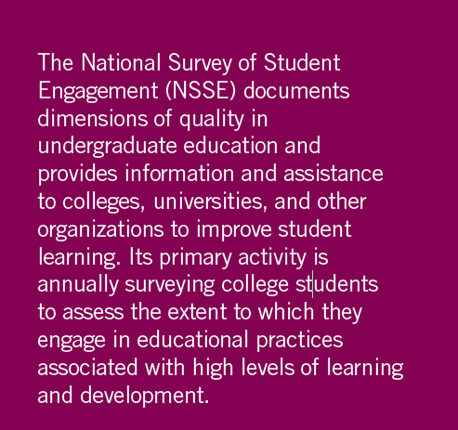
To support these efforts, the National Survey of Student Engagement (NSSE) introduced a special survey tool, NSSE Pulse, to aid institutions in responding to these new and shifting challenges regardless of course delivery method – in person, online, or a hybrid combination. The Pulse survey included select items from NSSE that matter to student engagement and persistence and new items to probe students’ experience in the unique circumstances of the pandemic. Pulse provided participating institutions quick results about key student engagement behaviors and other experiences to diagnose strengths and shortcomings to inform campus action. (Refer to Appendix A for information about survey administration details.)

In this report, we describe aggregate findings from the fall 2020 NSSE Pulse administration at 181 U.S. institutions to provide information about the undergraduate experience during the pandemic and suggest what colleges and universities might explore to address concerns about the quality of undergraduate education.

Suggested citation: National Survey of Student Engagement (2021).The COVID Pivot and Quality of the Undergraduate Experience: NSSE Pulse Project Report. Bloomington, IN: Indiana University Center for Postsecondary Research.

Data Featured In This Report
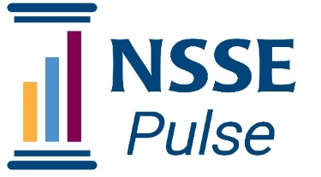
Approximately 1.2 million bachelor’s degree-seeking students attend the colleges and universities that participated in NSSE Pulse. These institutions reflect the diversity of U.S. bachelor’s-granting colleges and universities with respect to institution type, public or private control, size, region, and locale (see Appendix A). A list of participating institutions is available on the NSSE Pulse website.

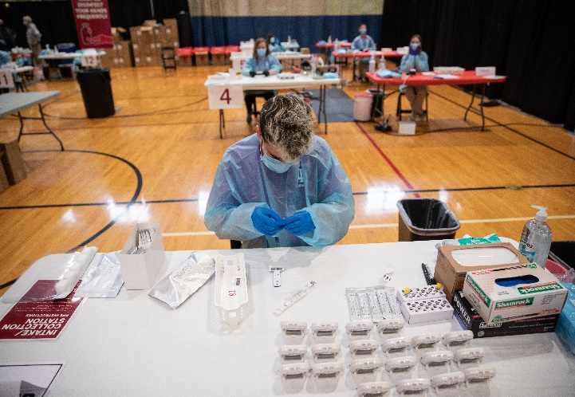
Approximately 120,000 students completed the Pulse instrument with institutions contributing an average of 666 respondents (median = 364, range 49 to 4,674). Respondents represented all four class levels: 30% first-year, 19% sophomore, 24% junior, and 27% senior. The vast majority of institutions administered the survey to all four classes while 15 institutions chose a more targeted approach. Students who identified their class level as “unclassified/other” have been excluded from this report to ensure a sharp focus on undergraduate students.
Photo credit Indiana University
NSSE Pulse Rates: Quick Facts about the Fall 2020 Experience
- 68% of respondents described their mix of courses taken as “mostly remote” with another 20% in “mostly hybrid or blended” and only 7% in “mostly in-person” courses
- 70% of students believed the institution helped keep them safe and healthy this school year
- 2 out of 3 students responded that their institution provided substantial (“very much” or “quite a bit”) support to help them succeed academically
- Only 46% of students reported their courses highly challenged them to do their best work (6 or 7 on a seven-point scale)
- Among the conditions for online learning, students were least likely to agree that their study spaces were sufficient for their needs
- The vast majority of students rated their quality of interactions with students, faculty and academic advisors as “excellent” or “good”

NSSE Pulse Findings
In this section we offer eight headline-level insights from NSSE Pulse results. Each headline includes discussion of implications and recommendations for colleges and universities.

1. The semester was tough, but most students evaluated their overall educational experience positively.
By all accounts, fall 2020 was challenging for everyone—students, faculty and staff, and institutions. Yet, three of four students evaluated their entire educational experience highly (“excellent” or “very good”). Controlling for various student- and school-level characteristics, students who did not evaluate their experience highly were somewhat more likely to be male, studying mostly online, have a learning disability, mental health disorder, or multiple impairments, be of American Indian or Alaska Native, African American, or Middle Eastern/North African background, and enrolled at a public or minority-serving institution. Of these characteristics, being homeless (about 400 respondents) was most strongly related to a “Fair” or “Poor” evaluation of the experience.

Open-ended student comments (from approximately 34,000 students) and the selected comments displayed in Figure 1 “What Students Say: Most Satisfying, Most Disappointing” revealed overall appreciation for “the kindness of professors” and professors who “really understand the struggles that we have in this unpredictable condition,” their “interactions with other students,” and “low COVID numbers” at their campus.

On the other hand, students who did not evaluate their experience highly expressed disappointment across a range of topics, focusing mainly on “missed social interaction,” the “uncertainties of the required shift to online learning,” “communication lapses,” and “health and safety concerns”.

Overall, what students said about their most satisfying and most disappointing experiences was thoughtful and respectful and demonstrated understanding of the challenging circumstances.

“While the professors seem a little overwhelmed with their workload, I feel that they genuinely care for their students’ learning and do their best to make time to address concerns and questions” First-Year Student, living within commuting distance

Figure 1. What Students Say: Most Satisfying, Most Disappointing

Selected comments about what is most satisfying among students who evaluated their experience as “excellent” include: | Selected comments about what is most disappointing among students who evaluated their experience as “poor” include:
“Connecting with professors who really seem to care about you”  “Learning new information and becoming online friends with my biology group”  “Being able to attend classes”  “Not commuting this year. The teachers are still top notch though some are better at internet teaching than others”  “Being able to finish my degree”  “The community of students and seeing others struggling just like me knowing if they can do it I can do it. Many encouraging others” | “Learning online”  “Some professors are not caring. Some don’t respond to students”  “Lack of patience and understanding from professors”  “Not being able to be on campus/lack of social interaction leading to the depletion of my mental stability”  “I am really upset with the way we have been handling social interactions for students. I understand keeping us safe but at what cost? Our mental health is awful and there is no where to do homework and or group projects.”

IMPLICATIONS FOR INSTITUTIONS: Students, faculty, and staff seem to have afforded one another much-needed grace during this unprecedented period. However, overall satisfaction should continue to be monitored at all institutions, particularly among student populations who evaluate their experience at low levels. Equally important, how might institutions honor and recognize faculty and staff for their commitment and continue to assure students are treated with grace and respect given challenging circumstances?

2. A majority of students said their institution supported their academic success.
Two out of three students said their institution substantially (“very much” or “quite a bit”) emphasized providing support to help them succeed academically. First-year students were more likely than others to report their institution supported them academically. On the other hand, one-third of students did not indicate this level of academic support. Controlling for various student- and school-level characteristics, students who responding at the low end of the scale (“some” or “very little”) were more likely to be studying online, living in Greek housing, homeless, have a learning disability, mental health disorder, or multiple impairments, or attend a public institution.

To get further insight into what explains students’ low perceptions of academic support, we reviewed open-ended comments. Comments from students with low perceptions of academic support revealed concerns about unclear communication, frustration with remote learning technology including faculty struggles with technology, a proliferation of learning platforms, and confusing communication channels, as well as difficulty getting assistance and a general sense of being overwhelmed and unsupported. The direct quotes in Figure 2 “Concerns of Students with Low Perceptions of Academic Support” illustrate students’ specific concerns.
“Lacking or completely absent communication from most professors putting an undue amount of stress of students”
“Vast amounts of professors that lack communication and technology skills”
“It’s hard to get a hold of anyone to get help”
Figure 2: Concerns of Students with Low Perceptions of Academic Support
“Lacking or completely absent communication from most professors putting an undue amount of stress of students”
“Vast amounts of professors that lack communication and technology skills”
“It’s hard to get a hold of anyone to get help”
“Heavy coursework despite the pandemic”
“A lack of compassion from some instructors despite the current circumstances”
“There’s been no effort to introduce online only students to each other, and professors assigning so much work yet offering such little help”
“Weed out classes still existing during such a stressful, hard time. Students need more academic support than ever.”
“Academic advisors not reaching out to help or communicate regularly with students. Some professors using online only formats are hard to reach and I feel as if I am teaching myself everything and am not absorbing any information.”
“A lot of instructors show little care for struggling students.”
“Overwhelmed with reading, videos, and writings without any human interaction. More time on a laptop does not equate to a healthy college experience and I want to have more interaction with faculty and students on a personal level to exchange ideas and opinions.”

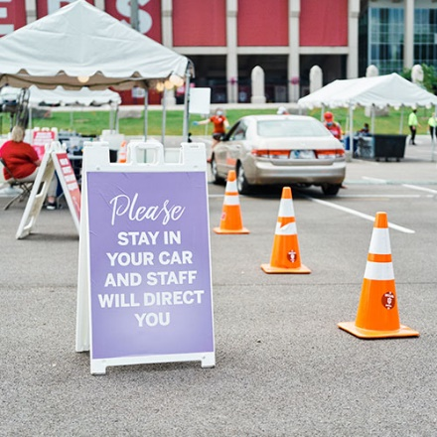
IMPLICATIONS FOR INSTITUTIONS: The one-third of students who indicate low levels of academic support deserve attention. The challenges students indicated include confusing communication about courses and resources, uncoordinated digital learning tools, and a general lack of support. While understandable given the circumstances, these matters can be improved. Faculty and staff efforts to reach out to students—or perhaps a peer advising outreach initiative—and to check-in on how students are managing might help create a more supportive environment for learning.
Photo credit Indiana University

3. Sufficient study space was a challenge for many remote learners.
Among the three conditions for online learning addressed on the Pulse survey – Internet service, hardware and software, and study space sufficient for academic work – students were least likely to agree that their study space was sufficient for their needs. In fact, nearly twice as many students disagreed that they had sufficient study space (23%) compared to sufficient Internet access (14%). Access to sufficient study space was most commonly cited regardless of residence, but it was a greater problem for those living off campus (24% disagreement versus 19% among those living on campus).

IMPLICATIONS FOR INSTITUTIONS: Colleges and universities should recognize and help identify solutions to the challenge of study space. Tapping the expertise of learning support staff who can advise students about how to create a productive space for studying at home, or to consider how to set up physically-distanced and safe spaces for studying on campus or in commonly available spaces off campus (e.g., public parks and picnic areas) may be helpful. Faculty who teach online classes should ask students about study space, encouraging them to share what works and what might be needed for success given the assignments and expectations in their courses. Again, learning support staff, librarians, and peer mentors could provide helpful advice to students and help faculty facilitate information sharing and getting students connected with campus support services.

“They have found ways to make some classrooms available for students to sit in to do work because for some of us working from home can be tough or distracting.” Junior, Research University, Living in a house or apartment

4. Students rated their quality of interactions with advisors the highest, followed by faculty and other students.
Fifty percent of students rated the quality of their interactions with advisors as excellent (6 or 7 on a 7-point scale) followed closely by faculty (47%) and other students (44%). Interactions with student services staff and other administrative staff and offices were rated lower (under 40% rated excellent). These percentages are somewhat lower than aggregate results from recent NSSE administrations, but the overall pattern closely mirrors results from annual NSSE administrations. First-year students had the highest average Quality of Interactions scale score among all class levels, suggesting that significant attention was placed on ensuring new students experienced positive and supportive connections with faculty, advisors, and others.
IMPLICATION FOR INSTITUTIONS: Given positive advisor and faculty influence, institutions might remind these agents of their impact and encourage them to reach out and ask students how they’re coping and to help connect them to support resources.

5. Despite physical distancing requirements and shifts to remote instruction, students’ sense of belonging—an expression of their connection to the institution and feeling valued—was strong.
Nearly 75% of students felt like they were part of the community at their institution and about the same proportion felt valued by their institution. However, this also reveals that one in four students did not feel they belong.

Notably, even during a disrupted semester, the average sense of belonging score for first-year students (43 on a 60 point scale), was generally comparable to NSSE 2020 results (see Annual Results 2020, Building a Sense of Community for All). Sense of belonging scores (1-60 points) among all students were also relatively comparable across racial/ethnic groups, though lowest among students who selected “another race or ethnicity” or who preferred not to respond (Figure 3).

Sense of belonging results are also discussed in the expanded section, “What Matters to Sense of Belonging and Quality of Interactions?” (p. 10). Controlling for various student and institutional characteristics, the analysis demonstrates that mostly remote instruction is associated with lower sense of belonging and quality of interaction scores.

IMPLICATIONS FOR INSTITUTIONS: While many changes associated with the pandemic— physical distancing, remote instruction, and cancelled campus events—can undermine sense of belonging, students managed to find belonging in what was provided. This also suggests that institutions were responsive to students’ needs. Institutions should investigate what helps students feel like they belong and are valued and ensure these aspects of college life continue or are amplified. For further outreach, invite faculty and staff to ask new students how they can help them get connected to the institution. Ask first-year students if they’ve been involved in the way they expected—what were they most looking forward to and how might some aspect of this be provided even under current circumstances?


6. Student satisfaction with Internet access was lowest among students living on campus.
Although only 14% of students taking online courses disagreed or strongly disagreed that their Internet service was sufficient to participate in courses, students who lived on campus were twice as likely to disagree compared to those living off campus (22% versus 11%).

IMPLICATIONS FOR INSTITUTIONS: Although the finding that campus Internet service is less favorable may counter the prevailing view of high-tech campus services, it may be that older campus housing units have not kept pace to meet the demand of all students being online for instruction. It is also possible that students living on campus have higher expectations for good connectivity.

7. The small share of students experiencing mostly in-person instruction had more favorable learning experiences than those in mostly remote or hybrid courses.

Although 88% of students experienced mostly remote or hybrid instruction, the 7% of students reporting mostly in-person instruction had significantly more favorable scores across all measures. More than 80% of students reporting mostly in-person instruction said their institution provided substantial support to help them succeed academically compared to 68% for mostly remote or hybrid instruction. They also rated their quality of interactions with faculty and peers more highly, and the share with a favorable evaluation of their entire educational experience at the institution was 10 percentage points higher than among those experiencing mostly remote or hybrid instruction (85% versus 75%). Controlling for a host of student and institutional characteristics, those who studied mostly in-person had modestly higher opinions of their interactions with others and sense of belonging. Figure 4 illustrates the percentage of students who rated their overall educational experience as excellent or good by course modality.
Photo credit: Indiana University

IMPLICATIONS FOR INSTITUTIONS: Given the abrupt shift to remote and hybrid instruction it is not surprising that in-person instruction is viewed more favorably by students and is the mode of instruction associated with more positive experiences. Collecting information about what worked and what was challenging might help institutions evaluate conditions for remote instruction that can be improved given the expectation for more online instruction post-pandemic. (NSSE 2021 includes an optional Experiences with Online Learning Topical Module and results will reveal more about how students engage in both online and hybrid courses.)
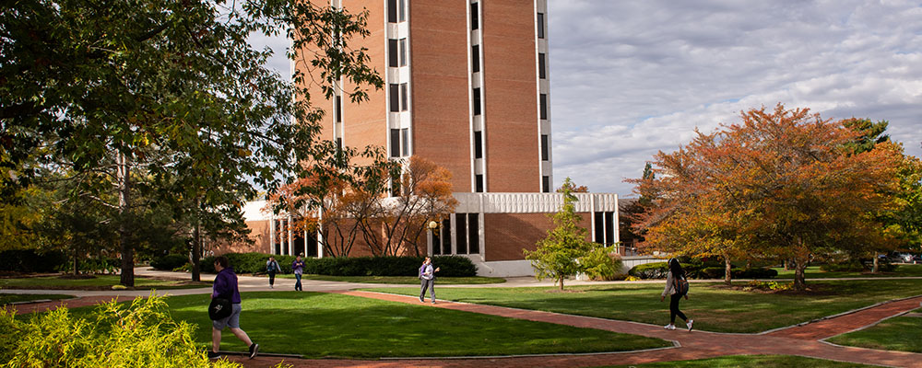
Photo credit: Ashland University

8. Students largely believed their institution helped keep them safe and healthy.
The majority of students (70%) believed their institution substantially (“very much” or “quite a bit”) helped keep them safe and healthy. Yet despite required adjustments to remain compliant and safe, about 50% of students reported concerns that others were not complying with institutions’ health policies.

IMPLICATIONS FOR INSTITUTIONS: Extensive testing, sanitation, and requirements for masks and physical distancing helped students feel safe. In turn, feeling safe has probably helped students feel more comfortable overall with course changes and other pandemic stresses and institutions should be applauded for their management of health and safety. However, the need to hold all students to safety standards was not lost on students—they noticed peers failing to observe protocols.

Students’ comments about health and safety…
“Although it is challenging, I am so happy I’m being kept safe.”
“I am impressed with the handling of COVID procedures. We've had
few positive tests… and I think that can be relatively difficult to achieve.”
“There has been almost no social interaction in class or outside of class
due to COVID-19.”
“Most students don’t wear masks or social distance on campus.”
“We should all have been tested prior to coming back to school, very
disappointing.”
NSSE Pulse included two scales—Sense of Belonging and Quality of Interactions—known to be associated with student persistence and success. Investigating what accounts for scores on these scales suggests where institutions might focus some attention. Controlling for various factors, what affects these scores?
Average scores for Quality of Interactions and Sense of Belonging show modest but statistically significant differences between students taking their courses mostly online and their peers who were not. For instance, students reporting mostly remote instruction scored three and five points lower on the 60-point Sense of Belonging and Quality of Interactions scales relative to students studying in-person, respectively (approximately a .15 and .19 standardized effect with various student and school-level controls). We found similar but slightly smaller significant effects for students reporting a balanced mix of various formats relative to those studying mostly online.
Additionally, students reporting mostly remote instruction evaluated their overall educational experience more negatively. Those studying mostly in-person or with a mix of formats showed advantages of about 11 and 8 percentage-points, respectively, over their peers experiencing mostly remote instruction. As in the analysis above, students experiencing mostly hybrid instruction showed similar results but to a lesser degree.
This analysis demonstrates that even after controlling for student and institutional characteristics, mostly remote instruction was associated with lower sense of belonging and quality of interactions. Given this result, colleges and universities should consider approaches to bolster interaction in remotely delivered courses and build in occasions, activities, and assignments to connect students to the campus and ensure they feel valued. Strategies to positively influence belonging and interaction through remote instruction should be considered in the near term, along with efforts to make up for these critical facets of students’ experience post-pandemic.
These results should not be read as a broad indictment of online learning. U.S. higher education confronted a sudden shift to largely remote instruction, requiring faculty and students to make quick adjustments to teaching and learning. Colleges and universities did their best to assist faculty in making the transition, but more time and resources devoted to planning and training would surely have resulted in more positive and effective teaching and learning experiences.
The simple descriptive statistics below are complemented by multi-level model results controlling for various student and school-level controls.

NSSE Pulse 2020 Sense of Belonging, Quality of Interactions, and Rating of Overall Educational Experience Results
Instructional Modality | Average Sense of Belonging Scoreª | Average Quality of Interactions Scoreª | Overall Educational Experience^{b}
Mostly in-person instruction | 43 | 43 | 85%
Mostly remote instruction | 40 | 38 | 74%
Mostly hybrid or blended | 41 | 41 | 78%
A balanced mix of formats | 42 | 42 | 82%
ªScored on a 60-point scale. ^{b}Percentage reporting “Excellent” or “Good.”
What Matters to Sense of Belonging and Quality of Interactions?
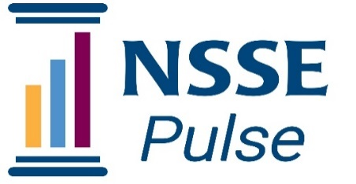

Final Thoughts
By and large, institutions and students adapted to and managed reasonably well in fall 2020 under dramatically changed circumstances. Open-ended comments affirmed that students appreciated being able to continue their education despite these changes. Most students engaged with their learning and demonstrated understanding about the adaptations necessary for safety. Their disappointments were understandable, and mainly focused on lost opportunities to be with friends and to experience campus life and to be involved in organizations, clubs, and special learning experiences. Most students expressed appreciation for efforts by faculty and staff to be creative in offering virtual or distanced events and instruction and efforts such as mask policies and mitigation testing to keep everyone safe.

Although NSSE Pulse aggregate results shine a light on the undergraduate experience during a pandemic, the results are most meaningfully examined institution by institution, and within institutions by important factors such as course modality and residence, as well as student characteristics including year in college, first-generation status and racial/ethnic identity. This is where important variations exist and institutions are able to be responsive. Pulse participating institutions are encouraged to examine their results using relevant filters to gain a more nuanced understanding of what students are experiencing and where attention is needed.

Notably, students’ open-ended comments were most critical of unclear communications about how the pandemic would affect course availability, faculty furloughs, academic calendars, residence, and dining. Ensuring that communications are clear and consistent is vitally important. In addition, students expressed stress and commented on the potential for burnout with new calendars and no breaks. Many students noted the need for access to counseling and other mental health services to ensure their well-being, and some indicated greater needs given pandemic stressors.

Students also indicated relatively high levels of support for their academic success and overall well-being. Students’ sense of belonging results were not much different than pre-pandemic levels, with an understandable reduction in students reporting that they feel a part of the community at the institution. Overall, findings suggest that institutions were responsive to students’ needs during the fall and that most key indicators of engaging educational experiences were sustained.

NSSE Pulse results provide all colleges and universities valuable insights about students’ experiences. Most important is the need for all institutions to continue asking students how they are doing and to use evidence to guide decision-making and to develop a plan for responding to student concerns.

Appendix A

The main section of the Pulse survey included items focusing on academic challenge and success, interactions with peers, faculty, and staff, sense of belonging, conditions for online learning, concern for health, and adherence to health policies. The demographic section included current living situation and demographic information about students (race/ethnicity, gender identity, sexual orientation, and disability).

Pulse was in the field from October 5 through November 23, 2020.

Participating institutions self-selected into the survey and chose which students to invite. The project only required that participants be undergraduates (though some institutions asked for and received permission to target others such as graduate students, a population excluded from this report). Sampling was at the discretion of the institution but large institutions were asked to limit their survey sample to 20,000. Institutions were responsible for survey recruitment, meaning they could contact students using email, learning management systems, or other means to encourage survey participation.

Each institution received one unique survey link for the administration. Consequently, all respondents are anonymous. Participating institutions received their data via private institutional dashboards in October 2020.

Table A1. Profile of NSSE Pulse 2020 U.S. Institutions and Respondents and Bachelor’s-Granting U.S. Institutions and Their Students
 | Institutions  (%) |  | Students  (%)
Institution Characteristics | Pulse | U.S. | Pulse | U.S.
Carnegie Basic Classification
Doctoral Universities (Very high  research activity) | 10 | 8 | 29 | 30
Doctoral Universities (High research activity) | 9 | 8 | 15 | 16
Doctoral/Professional Universities | 12 | 9 | 10 | 10
Master's Colleges and Universities  (Larger programs) | 24 | 21 | 21 | 26
Master's Colleges and Universities (Medium programs) | 16 | 12 | 9 | 6
Master's Colleges and Universities  (Smaller programs) | 5 | 8 | 5 | 3
Baccalaureate Colleges—  Arts & Sciences Focus | 12 | 15 | 5 | 4
Baccalaureate Colleges—Diverse Fields | 13 | 19 | 5 | 5
Control
Public | 50 | 36 | 68 | 67
Private | 50 | 64 | 32 | 33
Undergraduate Enrollment
Fewer than 2,500 | 45 | 53 | 18 | 11
2,500–4,999 | 16 | 17 | 11 | 11
5,000–9,999 | 16 | 15 | 23 | 19
10,000 or more | 23 | 15 | 49 | 59
Region
New England | 8 | 8 | 7 | 6
Mid East | 24 | 18 | 17 | 16
Great Lakes | 22 | 15 | 22 | 14
Plains | 12 | 10 | 9 | 7
Southeast | 19 | 25 | 23 | 24
Southwest | 7 | 8 | 9 | 12
Rocky Mountains | 1 | 3 | 1 | 6
Far West | 6 | 10 | 11 | 13
Outlying Areas | 0 | 2 | 0 | 1
Locale
City | 49 | 46 | 56 | 61
Suburban | 18 | 26 | 20 | 24
Town | 28 | 22 | 23 | 14
Rural | 5 | 6 | 1 | 1
Notes: Percentages are unweighted and may not sum to 100 due to rounding. U.S. percentages are based on the 2018 IPEDS Institutional Characteristics data for institutions that award baccalaureate degrees. Carnegie classification results exclude 15 institutions that had other classifications from the ones listed in the table. For information on the Carnegie Foundation’s 2018 Basic Classification, see carnegieclassifications.iu.edu

