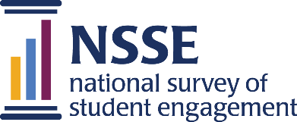 Lessons from the Field — Dispatch #1

Using NSSE Data in Strategic
Decision Making for Advising

Eastern Connecticut State University
Far from taking advising away from faculty, Eastern’s new advising model — based on both quantitative and qualitative data from NSSE — supported the faculty’s natural role as mentors for their students.
Dr. Elsa Núñez arrived as new president at Eastern Connecticut State University in 2006 with a reputation as a proponent of strategic planning and data-driven decision making. Within a year, more than 300 faculty and staff were hard at work crafting the first five-year strategic plan of her presidency. (As of this printing, the university is in the third planning cycle of the Núñez administration.)
One of the most important elements of Eastern’s 2008–2013 Strategic Plan was a multi-tiered advisement program driven by results from the National Survey of Student Engagement (NSSE) to overcome the politics of change. This initiative created an advising program that Eastern depends on to serve students and to help them persist on their path to academic success.
When the strategic planning committee charged with supporting student success looked at Eastern’s NSSE 2010 data, they paid particular attention to students’ written qualitative responses to the survey’s open-ended questions.
Eastern Connecticut State University
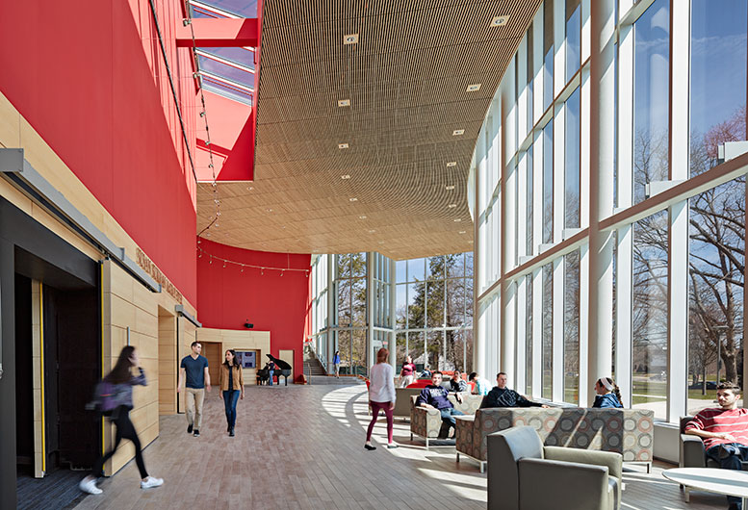
Student comments, such as the two below, clearly indicated that Eastern’s advising system was broken and that depending on faculty to advise students wasn’t working.
In This Dispatch
NSSE DATA IN strategic decision Making
Eastern Connecticut State University
IMPROVING the NSSE RESPONSE RATE
University of Missouri
Enhancing HIGH-IMPACT PRACTICES
Middle Georgia State University
PUTTING STUDENTS’ COMMENTS TO USE
Beloit College
San Francisco State University
Southern New Hampshire State University
This Dispatch is a supplement to NSSE’s multi-volume series Lessons from the Field.
For more institution examples, see Volume 4 or other examples online: nsse.indiana.edu/links/lessons
Suggested citation: National Survey of Student Engagement. (2019). Lessons from the Field—Dispatch #1. Bloomington, IN: Center for Postsecondary Research, Indiana University School of Education.
“Trying to figure out my major was hard, because I was not advised well at all.”
“I’ve seen my advisor only once all year; she causes me more stress than my schoolwork!”
The hard data from NSSE were also compelling. When asked if they talked with a faculty member about their career plans, only 46 percent of freshmen and 49 percent of seniors said yes. Asked to evaluate Eastern’s academic advising program on a scale of 1–5, students rated it only 2.9.
While the problem was clear enough, how to build a better advising system—one that the administration could sell to the faculty—was a challenge. Dr. Núñez felt she needed a faculty champion who could help to gain faculty buy-in and to ensure implementation at the academic department level. She found such a champion in an environmental earth science professor—a scientist and an award-winning teacher respected by his peers and loved by his students.
President Núñez asked this professor to work with her to convince the faculty that the new advising model—far from taking advising away from them—supported their natural role as mentors for their students. The plan was for a professional advising office to take over some aspects of advising outside of the faculty’s subject matter expertise so that professors could focus on providing students with program- and course-specific counseling and support. Faculty would also continue to have the critical role of advising students on career opportunities in collaboration with the Center for Internships and Career Development.
Eastern’s success in using data for strategic decision making in student advising has built confidence in using data to make other critical decisions that require innovation and change.
Dr. Núñez and her faculty champion went to each academic department to share NSSE data. They reminded the faculty that surveys such as NSSE are typically completed by self-motivated, higher-achieving students. If these students were having problems with the advising program, odds were good that the program needed to be stronger.
These discussions with faculty were not quiet conversations, Dr. Núñez recalls. The faculty challenged the model being presented and questioned the findings, but NSSE results were hard to ignore as they came directly from students. The fact that the faculty champion was a highly respected research scientist with student-centered classes was a major reason why the faculty were finally convinced to endorse the new advising model.
A student academic advising committee—also led by faculty members—was created to finalize the plan for a multi-tiered advising model. The new structure included a newly staffed office of professional advisors; clear roles for that office and for faculty; and programs to provide advising at four critical stages in a student’s life: (1) pre-enrollment, (2) first-year experience, (3) choosing a major, and (4) career planning. Eastern even brought advising into the residence halls so that students are “at home” when talking about their academic and career futures.
Using funds from a Title III grant, as well as other university resources, Eastern invested $4 million in the advising program. The year after the program was implemented, student satisfaction rose from 69 percent to 78 percent. NSSE data showed that from 2008 to 2012 student ratings increased 31 percentage points for faculty accessibility, 11 points for Eastern as a supportive campus, and 12 points for prompt feedback from faculty.
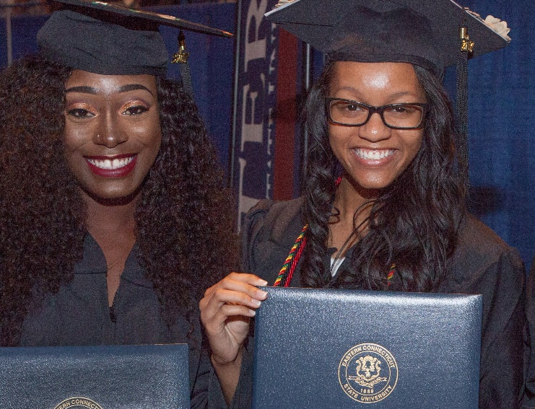
Eastern Connecticut State University
More recent data from NSSE 2017 compared Eastern to its peers in the Council of Public Liberal Arts Colleges (COPLAC) and found Eastern students outperforming their COPLAC peers when it comes to discussing careers and topics beyond the classroom with faculty.
Retention at Eastern has risen as well. The recent 2018 freshman-to-sophomore cohort was at an all-time high of 79.3 percent, up more than two percentage points from 2017 and almost six points from a decade ago. Knowing that this measure impacts graduation rates, even though Eastern’s four-year graduation rate is the highest in the Connecticut State University System, the university continues to work on it. Most important, however, is the success of individual Eastern students.
Eastern’s improvement of student advising is a good example of how the university uses data in making strategic decisions, and this success has built confidence in using data in other critical decisions that require innovation and change. Only by listening to student voices can colleges and universities ensure that the changes we make improve educational outcomes. Sharing credible data—the hard quantitative data as well as the anecdotal, qualitative data found in NSSE results—is a powerful way to mobilize faculty in leading change efforts and in making decisions to enhance student learning.

It Takes a Committee: Improving Mizzou’s NSSE Response Rate

University of Missouri
The University of Missouri resolved to use its NSSE results for strategic planning starting with the 2018–19 school year. To have more reliable data for planning and assessment, the university set the goal for its response rate at 30%—nearly double its previous response rate of 17%.
The committee’s NSSE Campus Tour revealed the close connection between the various groups across the university and the needs and activities of institutional research and assessment.

Mizzou’s Vice Provost for Institutional Research, and the Vice Provost Undergraduate Studies, in partnership with the Interim Vice Chancellor for Student Affairs formed a committee to focus on boosting NSSE response rates as well as increasing uses of NSSE data. The committee membership represented the Division of Student Affairs; the Office of Diversity, Equity, and Inclusion; the Office of Institutional Research; the undergraduate deans; the Honors College; the Center for Academic Success and Excellence; and an assistant professor in the Department of Educational Leadership and Policy Analysis who uses NSSE data in his research and explained in depth how NSSE data could be used by the different campus areas.
The main areas of the university’s strategic plan concerning the committee were those of students’ success and experiences. While the committee did not have a specific question in approaching NSSE data, they resolved during the year to develop a full plan for the use of NSSE data.
University of Missouri
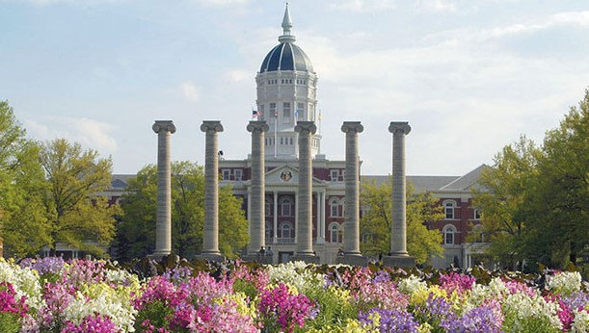
The NSSE Committee carried its message across the Mizzou community in a NSSE Campus Tour, meeting with advisors, undergraduate deans, social justice centers, and any other campus groups that regularly interact with students. The committee made presentations about the value of NSSE data, explaining how and why NSSE is important and how each group can use NSSE results. They also discussed methods to increase response rates of response to the survey.
These discussions revealed the close connection between the various groups across the university and the needs and activities of institutional research and assessment. This served to increase investment among the various representatives of these groups to more vigorously promote the survey to their students.
The Undergraduate Dean advocated using Canvas learning management system software this year. To advertise the survey, digital display screens across campus were used. Social media provided students easy access to Canvas. To boost the response rate still higher, students were offered attractive incentives—which had administration support because of the importance of NSSE in the strategic plan.
The incentives were a chance to win an Apple Watch Series 3, a $1,000 gift card for an Apple Product, an MU parking pass, or a $100 Mizzou Store gift card. These incentives certainly helped, but the buy-in from academic units helped even more. Fully 60% of the first-year students’ survey responses came via Canvas (the university’s learning management platform), a mode for responding that students likely considered trustworthy.
Mizzou’s campaign resulted in a final response rate of 44%—surpassing the university’s ambitious goal!
Looking ahead, the committee has noted that NSSE will be useful in continued implementation of the university’s strategic plan. The committee intends to meet again in the fall, when they will share this year’s NSSE results and develop methods to use them across campus. The work of the NSSE Committee at the University of Missouri demonstrates that campus partnerships are essential to the success of efforts to promote survey participation and to use survey results to improve undergraduate education.

Enhancing High-Impact Practices

MIDDLE GEORGIA STATE UNIVERSITY

In their 2015–2020 Quality Enhancement Plan (QEP) submitted to the Southern Association of Colleges and Schools Commission on Colleges titled “Experiential Learning@MGA,” Middle Georgia State University (MGA) planned to offer students an array of experiential learning opportunities including several High-Impact Practices (HIPs), with the goal of reinforcing the “student-centered focus of the university’s strategic plan.”
The experiential learning approach was selected after analysis of NSSE results and internal assessment data indicated MGA students were participating in some HIPs less frequently than their peers at comparison institutions. For example, NSSE data showed MGA seniors participated less often in undergraduate research, collaborative learning, and service-learning.
MGA’s QEP is designed to foster students’ progress through four tiers of experiential learning activities. Students are introduced to the QEP and experiential learning ideas at a “bronze level” event prior to their first experiential learning course or activity. They then have the opportunity to achieve “silver level,” “gold level,” or “platinum level” by completing additional qualified experiential learning courses and activities throughout their time at the university. MGA developed a rubric with specific evaluative criteria that allows them to qualify courses and activities as
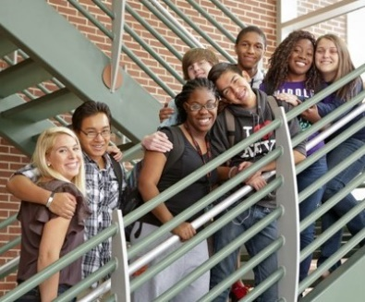
Middle Georgia State University
experiential learning and to help ensure consistency across these experiences. As MGA carries out their phased implementation of this QEP, NSSE will serve as an important assessment tool.

Putting Student Comments to Use

BELOIT COLLEGE

SAN FRANCISCO STATE UNIVERSITY

SOUTHERN NEW HAMPSHIRE UNIVERSITY

The Beloit College Office of Institutional Research, Assessment, and Planning (IRAP) reviews their NSSE student comments data for specific mentions of offices, services, and people. Compliments about the quality of services, the helpfulness of staff, or the encouragement of faculty are passed along to appropriate individuals. By sharing positive and sometimes constructive feedback from the Student Comments report, IRAP generates goodwill about NSSE and Beloit’s participation while also promoting the value of student voices in assessment.
San Francisco State University (SFSU) analyzed responses to the prompt “What one change would most improve the educational experience at this institution, and what one thing should not be changed?” Comments revealed three salient themes: class availability, graduation, and diversity. SFSU is using specific results to support positive aspects and minimize negative issues found in comments associated with these themes to help increase student engagement. SFSU’s student comments are displayed in attractive, colorful infographics available at the Institutional Research website.
At Southern New Hampshire University (SNHU) University College campus, NSSE results and questions that arise from them serve as the content of a one-credit School of Education course, “Inquiry Scholars.” Each semester, students enrolled in this course are asked to take up an authentic problem related to improving student learning that can be illuminated with their campus data. After SNHU’s administration of NSSE 2017, eight Inquiry Scholars classmates completed an analysis of the open-ended NSSE item, “What one change would you most like to see implemented that would improve the educational experience at this institution, and what one thing should not be changed?”
The Inquiry Scholars put each comment from the 270 respondents who answered this question on a strip of paper and sorted these into thematic affinity groups. After analyzing the
NSSE Student Comments Report
At the end of the core survey, students are invited to express their opinions about their college learning experience in a space for up to 5,000 characters. Institutions can choose one of four open-ended prompts:
- If you have any additional comments or feedback that you’d like to share on the quality of your educational experience, please enter them below.
- What has been most satisfying about your experience so far at this institution, and what has been most disappointing?
- Please describe the most significant learning experience you have had so far at this institution.
- What one change would most improve the educational experience at this institution, and what one thing should not be changed?

results by gender and year, they shared their findings with more than 150 faculty and staff members. Faculty, in turn, were asked to answer the same prompt during this event, and the Inquiry Scholars analyzed those results as well.

